Sponsorship Opportunities
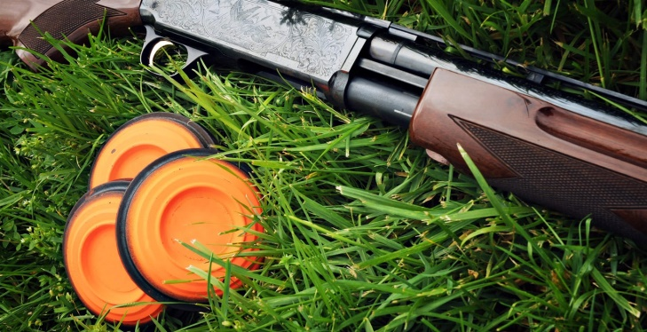
KRA Sporting Clays Classic

Jefferson Gun Club
June 13, 2022

Presenting Sponsor – Heartland $5,000

Registration for one team

A Station sponsorship
½ page ad in Kentucky Restaurant Journal
Recognition on social media
Recognition in event program and Kentucky Restaurant Journal

Sharp Shooter Sponsor – 3 available $1,500

Registration for one team

A Station sponsorship
Recognition in event program and Kentucky Restaurant Journal
Lunch Sponsor – 1 available $1,500

Awards Sponsor – 1 available $1,000
Seeking bourbon company for sponsorship plus
product for prizes

Station Sponsor – 15 available $ 250
Signage at Station
Recognition in event program

KRA SPORTING CLAYS TOURNAMENT

Jefferson Gun Club

June 13, 2022

- Presenting Sponsor - $5,000
- Sharp Shooter Sponsor - $1,500
- Lunch Sponsor - $1,500
- Awards Sponsor - $1,000
- Station Sponsor - $250

Contact Information:
Company: _____________________________________________________________
Contact:____________________________________ Title: ______________________
Address: ______________________________________________________________
Phone: ________________________ Email: _________________________________
In order to secure a sponsorship package, please complete & return this agreement to KRA office with full payment.

Total Amount $ _____________ Check enclosed or charge my credit card:
Please circle one: Visa MasterCard Discover American Express
Name on Card: ________________________________________________________
Card Number: ______________________________________ Exp. Date: __________
Signature: ______________________________________ Date: _________________
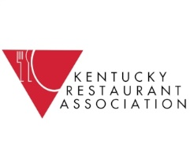
CVV Code: ____________

Official Signature: _____________________________________ Date: _____________
Mail Agreement & Payment to:
Kentucky Restaurant Association
133 Evergreen Road, Suite 201
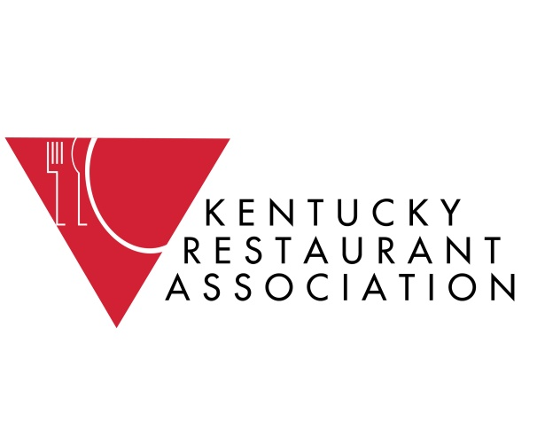
Louisville, KY 40243
502/400-3736
502/896-0465 fax

